**Wine Website Research**

**Website Design Ideas**

The design of our website/web-application will be inspired from a couple of different websites. In our website to list the different types of wines offered through the website. We would like to implement a slider similar to the one in the picture below. This design can be found at https://www.getwine.co.za/.

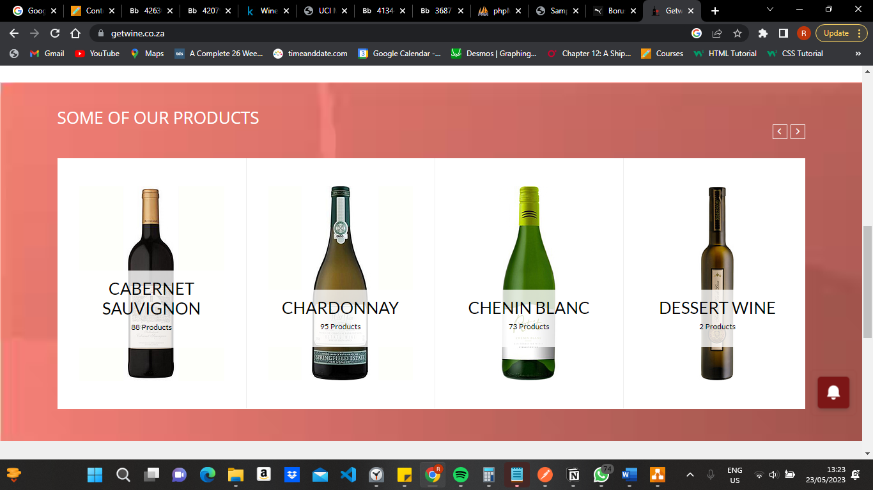

**Management of Users**

To manage the users and the logging in of users. We will have a page that will be used for logging in or signing up. The design inspiration of this page will be taken from the login and sign up page found at the page below <https://www.winecellar.co.za/customer/account/login/referer/aHR0cHM6Ly93d3cud2luZWNlbGxhci5jby56YS8%2C/>

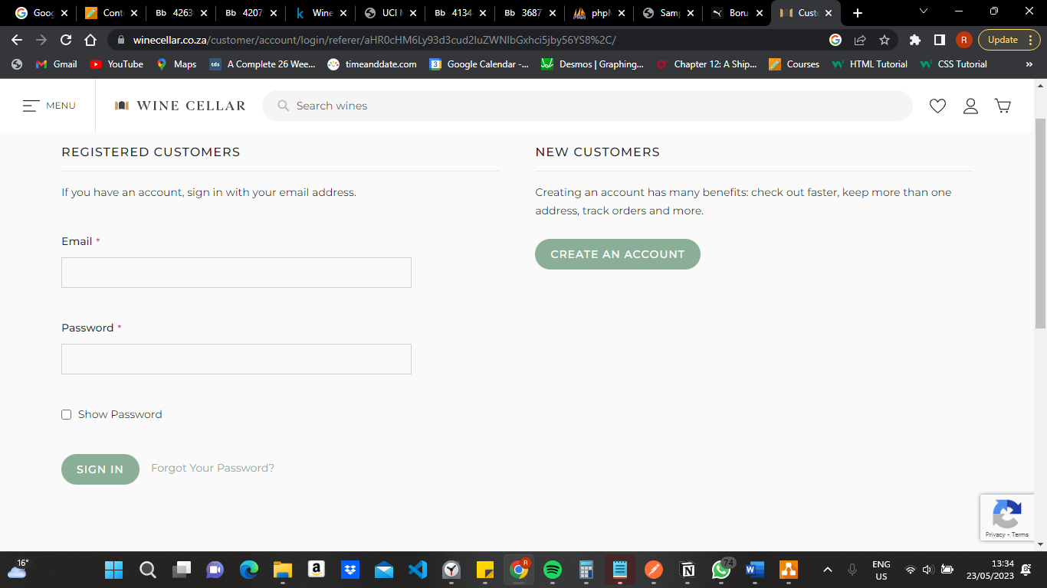

**Management of Verified Wineries**

In order to manage verified wineries we will have a column in our Winery entity which stores a validated value. We will then use this value to query all the verified wineries and display them on our website.

**Sorting application**

In order to implement our sorting we will have a sorting dropdown menu and based the sorting the user of the website selects functions in the backend will be executed in order to only show the wines according to the sorting option the user selected. An inspiration our design will take from is of the page below. The page is found at: https://www.winefolk.co.za/shop/?orderby=price

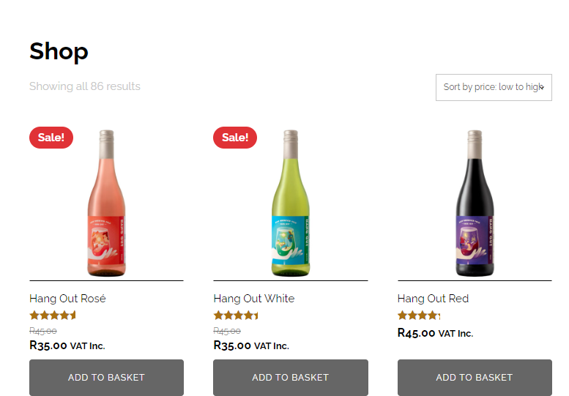

**Management of wine and winery information**

To manage the addition and removal of the wines. There will be specific users with privileges that allow them to add, remove and update wines that are listed on the website. This user will also be allowed to update, remove, and add information about wineries. These privileged users will be able to update any information on the wineries such as the wineries website, location, and address.

**Suggestion of the best destination based on location**

In order to suggest the best destination based on location we will ask the user which region they reside in. Based on the user’s response will execute a query which lists the best wineries in the region that they can visit. This will be displayed as a list on our website. Our list will be similar to the page below. Found at https://winefolly.com/lifestyle/wine-folly-names-top-wine-destinations-for-2022/

